XYZ Testing Lab

Random Vibration Test Report

SETUP NAME: ESS Random: VLTS Program
RUN NAME: run002 - Serial Number MRW32-Q
SAVE NUMBER: 1

STATUS INFORMATION
TEST EVENT TIME: Wednesday, August 03, 2016 at 04:00:53 PM
TEST STATUS: RUNNING
TEST MODE: AUTO
TOTAL TIME ELAPSED (HH:MM:SS): 00:45:28
AUTO TIME ELAPSED (HH:MM:SS): 00:44:48
TEST LEVEL: 0.0 dB
REFERENCE: 9.94 g rms
CONTROL: 10.01 g rms

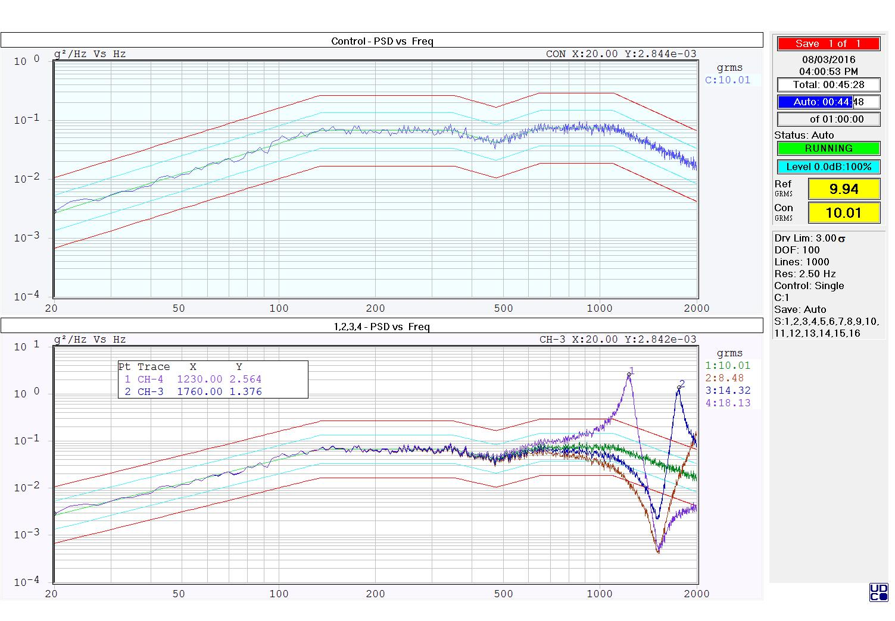

CONTROL PARAMETERS
CONTROL CHANNEL(S): 1
CONTROL TYPE: SINGLE
FREQUENCY RANGE: 2500 Hz
NUMBER OF PSD LINES: 1000
FREQUENCY RESOLUTION: 2.500 Hz
DOF: 100
AMPLITUDE DISTRIBUTION: GAUSSIAN
SIGMA DRIVE LIMITING: 3.00

REFERENCE BREAK POINT TABLE
BP  # | Freq  Hz | Level  (g²/Hz) | Slope  (dB/oct) | Alarm-  (-dB) | Alarm+  (+dB) | Abort-  (-dB) | Abort+  (+dB)
1 | 20.00 | 0.002655845 |  | -3.00 | 3.00 | -6.00 | 6.00
2 | 135.00 | 0.06639612 |  | -3.00 | 3.00 | -6.00 | 6.00
3 | 350.00 | 0.06639612 |  | -3.00 | 3.00 | -6.00 | 6.00
4 | 475.00 | 0.04149758 |  | -3.00 | 3.00 | -6.00 | 6.00
5 | 650.00 | 0.07303574 |  | -3.00 | 3.00 | -6.00 | 6.00
6 | 1100.00 | 0.07303574 |  | -3.00 | 3.00 | -6.00 | 6.00
7 | 2000.00 | 0.01659903 |  | -3.00 | 3.00 | -6.00 | 6.00

Accel: 9.94 g rms, Est. Vel: 6.67 in/s pk, Est. Disp: 0.0385 in pp, Ref. Disp: 0.0336 in pp

TEST STARTUP & SCHEDULE PARAMETERS
START LEVEL: -20.00 dB, (10.00% of full level)
AUTO RAMP RATE: MEDIUM
AUTO RANGE SETTLE PERIOD: FAST
AUTO MODE TIMER BEGINS AT LEVEL SCHEDULE STEP: ALL/ANY STEP(S)
TEST DURATION (HH:MM:SS): 01:00:00

LEVEL SCHEDULE
Step  # | Level  (-dB) | Level  (%) | Duration  (HH:MM:SS)
1 | 0.00 | 100.00 | 01:00:00

